**Experiment No. 06**

* 1. **Experiment Name**

Generate an algorithm and write a program on load flow study of a given power system using Newton Raphson method

* 1. **Objectives**
* To become acquainted with the load flow study of a given power system
* To learn how to generate a MATLAB code for numerical analysis using Newton Raphson method
* To get familiar with the procedure of designing and analyzing a power system in MATLAB
  1. **Theory**

Power system is a very large interconnected electrical network. So different techniques have been developed to analyze power systems. Node voltage method is one of those techniques.

The equations in the nodal admittance form result in a simultaneous complex algebraic equation in terms of load currents. Solving these equations gives the voltages and currents of the buses.

The biggest challenge in solving these equations is finding ***n*** unknown quantities from ***n*** nonlinear equations. Iterative methods are suitable for solving nonlinear systems of equations.

For this reason, iterative methods are suitable for solving node voltage equations. Net injected bus current has the relation. For a power system with ***n*** nodes the network equation where the current injected into the ***ith*** node can be obtained as $I_{i}= \sum_{k=1}^{n}{Y_{ik}V_{ik}}$

The power injected into the ***ith*** node can be written as

**= + =**

* 1. **Required apparatus**
* MATLAB
  1. **Block diagram**

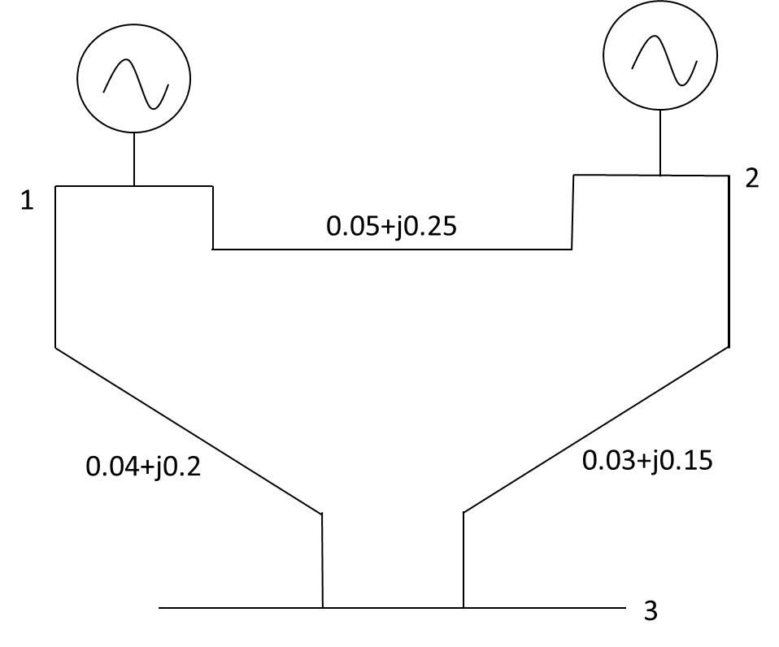

*Fig. 6.1: Diagram of a three- bus system*

* 1. **Data table**

|  |  |  |  |  |  |  |
| --- | --- | --- | --- | --- | --- | --- |
| **Bus** | **|v|** | **Pg** | **Qg** | **Pl** | **Ql** | **Angle** |
| 1 | 1.03 | 0 | 0 | 0 | 0 | 0 |
| 2 | 1.02 | 0.8 | 0 | 0.4 | 0.3 | 0 |
| 3 | 1 | 0 | 0 | 1 | 0.8 | 0 |

Fig. 6.1 Excel file of the Load data

|  |  |  |  |
| --- | --- | --- | --- |
| **Bus** | **Bus** | **R** | **X** |
| 1 | 1 | 0 | 1 |
| 1 | 2 | 0.05 | 0.25 |
| 1 | 3 | 0.04 | 0.02 |
| 2 | 2 | 0 | 1 |
| 2 | 3 | 0.03 | 0.15 |

Fig. 6.2 Excel file of the Impedance data

* 1. **Algorithm**

1. Start
2. Read an excel file that has bus numbers in the first two columns and resistance and admittance value in the third and fourth columns which represent impedance between the buses
3. Construct a matrix ***Mimp*** whose element ***ai,j*** denotes the impedance between i and j buses
4. Perform element wise inversion of ***Mimp*** matrix and keep it in y matrix
5. Use the formulas to construct the ***Ybus*** matrix $Y_{i,j}|_{i=j}=\sum_{0}^{j}{\frac{1}{y_{(i,j)}}} and y_{i,j}|_{i≠j}=\frac{-1}{y_{(i,j)}}$
6. Read the bus parameters from an excel file where P and V are defined for generator buses and P and Q are defined for load buses and P and δ are defined
7. Assume V = 1 and δ = 0° for nodes if not defined
8. Calculate the complex power as follows:
$S_{i}^{j}=(P_{g_{i}}-P_{l_{i}})+i×\text{Im}(V_{i}^{j-1}×({\sum_{k=1}^{n}{Y_{i,k}×V_{k}^{mostrecent}})}^{\text{*}})$

10. Calculate the jacobian $J=[\begin{matrix}H & L \\ M & N\end{matrix}]$ as follows:

$H=\frac{∂P}{∂δ}$; $L=\frac{∂P}{∂V}; M=\frac{∂Q}{∂δ}$; $H=\frac{∂Q}{∂V}$

1. where bus real power, $P_{i}=\sum_{j=1}^{n}{|V_{i}||Y_{i,j}||V_{j}|cos(θ_{i}-δ_{i}+δ_{j})}$ and bus reactive power, $Q_{i}=-\sum_{j=1}^{n}{|V_{i}||Y_{i,j}||V_{j}|sin(θ_{i}-δ_{i}+δ_{j})}$
2. Calculate the power mismatches as follows: $ΔP=P_{g}-P_{l}-\text{Re}(S)$ and $ΔQ={-Q}_{l}-\text{Im}(S)$
3. Calculate the phase and amplitude differences of buses using $Δ(δ,V)=J^{-1}×Δ(P,Q)$
4. Correct the bus voltages using $V^{i+1}=V^{i}+ΔV$ and $δ^{i+1}=δ^{i}+Δδ$
5. Calculate error as: - $ε=|V_{i}^{j-1}-V_{i}^{j}|$
6. If ε < tolerance value goes to next step otherwise go to step 8
7. End
   1. **MATLAB Code & Output**

clc; %Clears previous data from command window

clear all; %Removes all variables from the current workspace

cd('F:\Study material\Lab\3-2\Power System I'); %change the file directory

A = xlsread('EXp02p02'); %Read the excel file

n = length(A); %Determine the length of the excel file

% Applying symmetric condition

for w=1:n

Z(A(w,1),A(w,2)) = A(w,3)+i*A(w,4);

Z(A(w,2),A(w,1)) = A(w,3)+i*A(w,4);

end

m = length(Z); %Determine the length of the new matrix

for j=1:m

for k=1:m

if Z(j,k) == 0

Z(j,k) = inf;

end

end

end

fprintf(' Z matrix is \n') %Display the text

disp(Z) %Display the output

y = 1./Z %Taking inverse impedance matrix

p = sum(y,2) %Taking symmetric summation

%Apply looping condition to determine value of the matrix element

for u=1:m

for x=1:m

if u~=x

Y(u,x)= -y(u,x); %For diagonal element

else

Y(u,x)= p(x); %For non-diagonal element

end

end

end

fprintf(' Y- bus matrix is \n') %Display the text

disp(Y) %Display the output

cd('F:\Study material\Lab\3-2\Power System I'); %change the file directory

LFS = xlsread('Exp05'); %Read the excel file

busnum=LFS(:,1); bustype=LFS(:,1); nbus=length(busnum); voltage=LFS(:,2);

Angle=LFS(:,7); Pg=LFS(:,3); Pl=LFS(:,5); Qg=LFS(:,4); Ql=LFS(:,6);

P=LFS(:,3)-LFS(:,5); Q=LFS(:,3)-LFS(:,5); Psp=P; Qsp=P;

for j=1:nbus

v(j)=voltage(j)*exp(1i*Angle(j));

end

for i=1:nbus

bustype(1)=busnum(1);

if Pg(i)~=0&&Qg(i)==0&&v(i)~=1

bustype(i)=2;

else if P(i)~=0&&Q(i)~=0&&v(i)==1

bustype(i)=3;

end

end

end

w=real(v); u=imag(v); [del V]=cart2pol(w,u); vnew=V; w=real(Y); u=imag(Y);

[theta Y]=cart2pol(w,u); pv=find(bustype==2); pq=find(bustype==3);

npv=length(pv); npq=length(pq); delv=1; count=0; tol=0.1

v1=0;

v2=0;

v3=0;

V=vnew;

P=zeros(nbus,1);

Q=zeros(nbus,1);

for i=1:nbus

for k=1:nbus

P(i)=P(i)+(V(i)*Y(i,k)*V(k)*cos(theta(i,k)-del(i)+del(k)));

Q(i)=Q(i)-(V(i)*Y(i,k)*V(k)*sin(theta(i,k)-del(i)+del(k)));

end

end

dPp=Psp-P;

dQp=Qsp-Q;

k=1;

dQ=zeros(npq,1);

for i=1:npq

if bustype(i)==2

dQ(k)=dQp(i);

end

end

dP=dPp(2:nbus);

M=[dP;dQ];

J1=zeros(nbus-1,nbus-1);

for i=1:nbus-1

m=i+1;

for k=1:nbus-1

n=k+1;

if m==n

for n=1:nbus

J1(i,k)=J1(i,k)+(V(m)*Y(m,n)*V(n)*sin(theta(m,n)-del(m)+del(n)));

end

J1(i,k)=J1(i,k)-(V(m)*Y(m,n)*V(m)*sin(theta(m,m))); %hh

else

J1(i,k)=-(V(m)*Y(m,n)*V(n)*sin(theta(m,n)-del(m)+del(n)));

end

end

end

J2=zeros(nbus-1,npq);

for i=1:nbus-1

m=i+1;

for k=1:npq

n=pq(k);

if m==n

for n=1:nbus

J2(i,k)=J2(i,k)+(V(m)*Y(m,n)*V(n)*cos(theta(m,n)-del(m)+del(n)));

end

J2(i,k)=J2(i,k)+(2*V(m)*Y(m,n)*cos(theta(m,m)));

else

J2(i,k)=(V(m)*Y(m,n)*sin(theta(m,n)-del(m)+del(n)));

end

end

end

J3=zeros(npq,nbus-1);

for i=1:npq

m=pq(i);

for k=1:nbus-1

n=k+1;

if m==n

for n=1:nbus

J3(i,k)=J3(i,k)+(V(m)*Y(m,n)*V(n)*cos(theta(m,n)-del(m)+del(n)));

end

J3(i,k)=J3(i,k)-(V(m)*Y(m,m)*V(m)*cos(theta(m,m))); %h

else

J3(i,k)=-(V(m)*Y(m,n)*V(n)*cos(theta(m,n)-del(m)+del(n)));

end

end

end

J4=zeros(npq,npq);

for i=1:npq

m=pq(i);

for k=1:npq

n=pq(k);

if m==n

for n=1:nbus

J4(i,k)=J4(i,k)-(V(n)*Y(m,n)*sin(theta(m,n)-del(m)+del(n)));

end

J4(i,k)=J4(i,k)-(2*V(m)*Y(m,m)*sin(theta(m,m))); %h

else

J4(i,k)=-(V(m)*Y(m,n)*sin(theta(m,n)-del(m)+del(n)));

end

end

end

J=[J1 J2;J3 J4]

X=inv(J)*M;

dth=X(1:nbus-npq);

dV=X(npv+1:nbus);

for i=2:nbus

del(i)=del(i)+dth(i-1);

end

for i=1:nbus

k=1;

if(bustype(i)==3)

vnew(i)=V(i)+dV(k);

end

k=k+1;

end

for i=1:nbus

I=[vnew(i) del(i)];

end

%disp

count=count+1; delv=abs(vnew-V); I=[count vnew del delv];

disp('Iteration Magnitude Angle Error'); disp(I); Bus=busnum; Magnitude=vnew'; ang=radtodeg(del); Angle=ang';

T=table(Bus,Magnitude,Angle);

disp(T);

**Output**

**Z matrix is**

**0.0000 + 1.0000i 0.0500 + 0.2500i 0.0400 + 0.0200i**

**0.0500 + 0.2500i 0.0000 + 1.0000i 0.0300 + 0.1500i**

**0.0400 + 0.0200i 0.0300 + 0.1500i Inf + 0.0000i**

**y =**

**0.0000 - 1.0000i 0.7692 - 3.8462i 20.0000 -10.0000i**

**0.7692 - 3.8462i 0.0000 - 1.0000i 1.2821 - 6.4103i**

**20.0000 -10.0000i 1.2821 - 6.4103i 0.0000 + 0.0000i**

**p =**

**20.7692 -14.8462i**

**2.0513 -11.2564i**

**21.2821 -16.4103i**

**Y- bus matrix is**

**20.7692 -14.8462i -0.7692 + 3.8462i -20.0000 +10.0000i**

**-0.7692 + 3.8462i 2.0513 -11.2564i -1.2821 + 6.4103i**

**-20.0000 +10.0000i -1.2821 + 6.4103i 21.2821 -16.4103i**

**J =**

**5.5592 -6.5385 6.5385**

**-6.5385 16.8385 41.9385**

**1.3077 -21.9077 32.3923**

**Iteration Magnitude Angle Error**

**1.0000 1.0300 1.0200 1.0052 0 0.0742 0.0052 0 0 0.0052**

**Bus Magnitude Angle**

**___ _________ _______**

**1 1.03 0**

**2 1.02 4.2497**

**3 1.0052 0.29937**

* 1. **Discussion & Conclusion**

In this experiment, we designed an algorithm, flow chart, and programmed a generalized code for load flow study of a given power system. The sinusoidal steady state of the entire system is provided by the load flow. The code was generated to read the bus parameters from another excel file, solve the bus voltages, and then calculate the admittance matrix using impedances in an excel file.

The only adjustment to the code we may need is changing the directory of the file to work with and the given data saved inside the file. The bus numbers and the resistance and reactance values must also be given in the order defined for the code to work and give accurate result.